**PROJECT TITLE:**

**3-D Builder using Work- Fusion**

1. Firstly, user has to check whether the hollow tag folder exists on desktop or not. Folder must consist of two different .xlsx documents. User has to open hollow_tag.xlsx file
2. User has to make entry in hollow_tag.xlsx file.

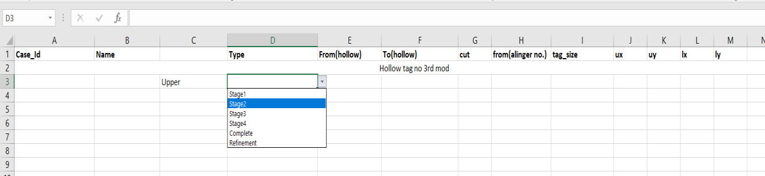

1. Entries of excel sheet are starting from A31. Case-id of patient is filled in A column. The case-id should be numeric with ten digits.
2. User must follow the following protocol to make appropriate entries in excel sheet.
   1. The initials of name are filled in column B. Suppose a person is having the name Virat Gupta then entry of column is written as VG_. If there is no surname of person then first two letters of name are taken. For same name Virat entry should be like this Vi_.
   2. Column C defines the arch whether we have to perform action on upper arch, lower arch or both. Drop down option is available to specify the arch.
   3. Column D defines the type of stage. We have total six stages (stage1, stage2, stage3, stage4, complete and refinement). It is also selected by drop down feature.
   4. Column E and F defines the starting and ending of sub steps. From which sub step we have to start hollowing our model and to which model we have to stop it.
   5. Column G defines the base cut size, which is cut in 3-D builder.
   6. Column H defines the aligner number. It is not necessary that aligner no. and sub step no. will match. That’s why we have to define them separately. Column I defines the tag size.
   7. Column J, K, L, M define the coordinates of tag. User can check the coordinates using a desktop app **Mouse-position-32 bit**. User can found this app on desktop. ux defines the upper arch x coordinate and uy defines the upper arch y coordinate. lx defines the lower arch x coordinate and ly defines lower arch y coordinate.
   8. **User must open the E drive in my pc before playing the recording. The E drive must be opened in maximised mode.**
3. After filling the entries user must save the file and launch the work-fusion application or you can run the application from right taskbar.
4. After launching application user have to open script file to play recording. It may appear on screen or not. So user must go to window->show view>other.

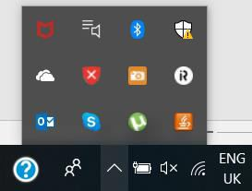

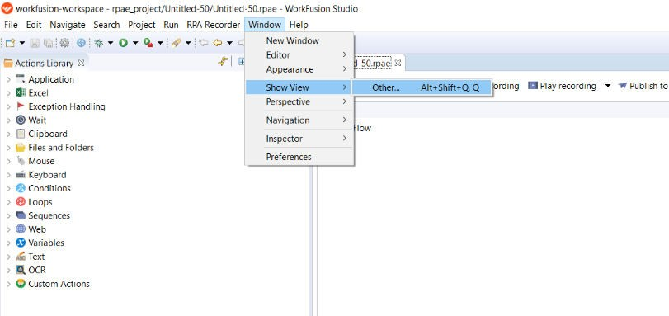

1. A dialog box will appear on the screen. Click on the media files and open it. Media files will be opened in the left side corner.

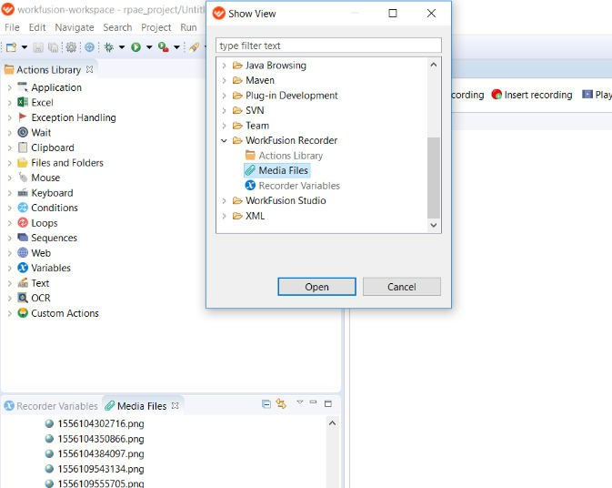

1. Double click on the **3-d Builder** folder. Then click on the **3-d Builder**.rpae . The file will load on right side.
2. Click on the play recording to run the file. After we run the file a small window appears on the right side window.

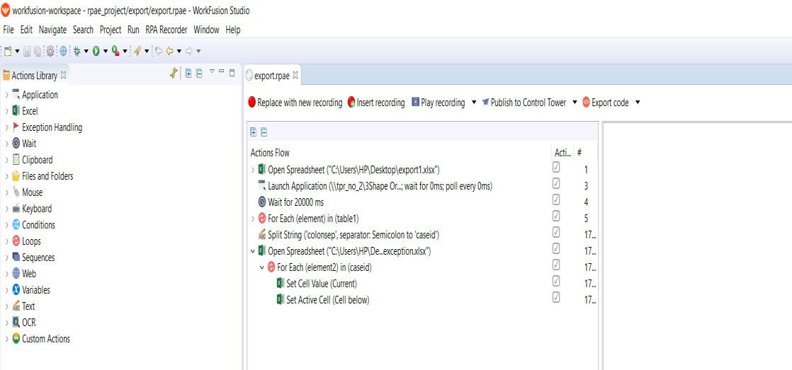

1. The window that appears on the right side must be shifted in upward direction to some extent.

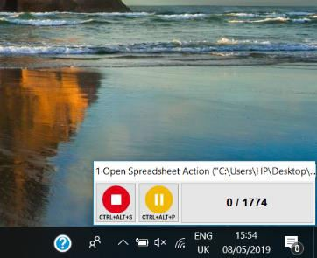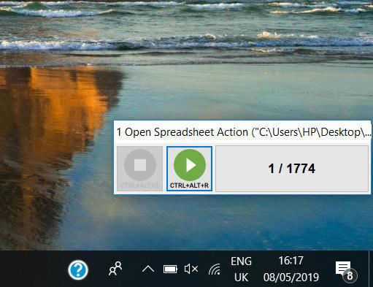

1. Sometimes it may execute an error like couldn’t connect to bot. In that case user must restart bot manager. User must check bot manager is always running.

